**Client Listing**

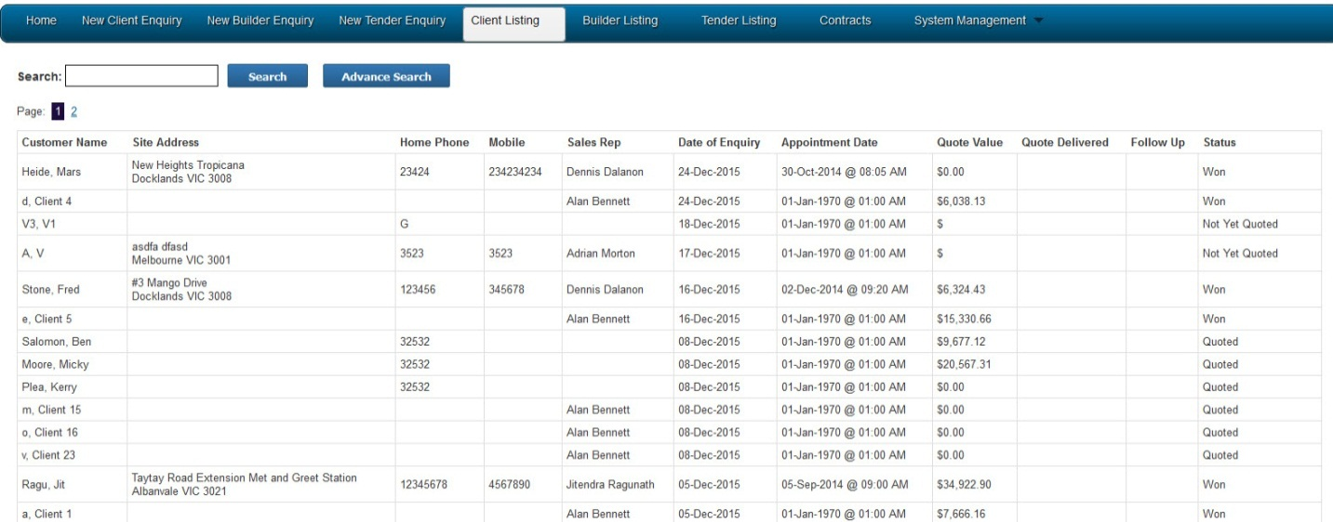

**List of Created Quote**

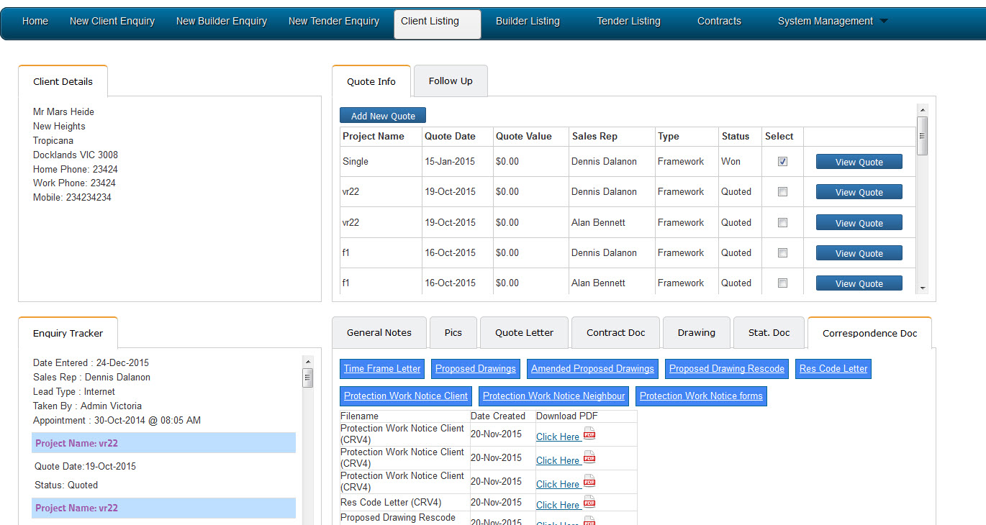

**Created Quote**

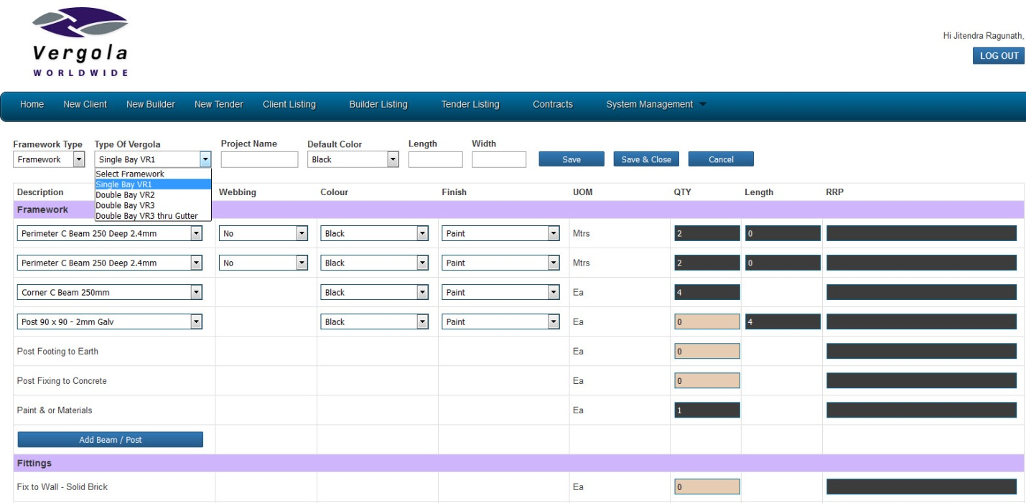

**List of files that are used for this section**

project_folder/includes/vic/quote/addquote_vic.php

project_folder/includes/vic/quote/singlebay_vic_vr1.php

project_folder/includes/vic/quote/doublebay_vic_vr2.php

project_folder/includes/vic/quote/doublebay_vic_vr3.php

project_folder/includes/vic/quote/doublebay_vic_vr3_thru_gutter.php

viewing part:

project_folder/includes/vic/quote/view/viewquote_vic.php

project_folder/includes/vic/quote/view/view_singlebay_vic_vr1.php

project_folder/includes/vic/quote/ view/view_doublebay_vic_vr2.php

project_folder/includes/vic/quote/ view/view_doublebay_vic_vr3.php

project_folder/includes/vic/quote/ view/view_doublebay_vic_vr3_thru_gutter.php

**JS File**

singlebay_vr1.js

doublebay_vr2.js

**List of tables used**

ver_chronoforms_data_followup_vic

ver_chronoforms_data_quote_vic

ver_chronoforms_data_inventory_vic

ver_vergola_default_framework_items

**Any plugins we used**

(Basic Joomla CMS)

tiny_mce

TCPDF

**List of required fields**

Project name, framework type, length, length 2, width

**List of business rules**

Input a

**List of files that are used for this section**

project_folder/includes/vic/enquiry/client_folder_vic.php

project_folder /includes/vic/quote/followup_vic.php

project_folder/includes/vic/enquiry/client_listing_vic.php

**List of tables used**

ver_chronoforms_data_followup_vic

ver_chronoforms_data_quote_vic

ver_chronoforms_data_contract_list_vic

**Any plugins we used**

(Basic Joomla CMS)

**List of business rules**

Make sure to select the framework type to load the preloaded items for the selected vergola.

Framework Items:

All posts are always 4 meters

Every bay is always has 4 pcs. of posts.

Every additional bay will need 2 extra post.

Materials and / or paint should be VR 1 = 1 , VR =2, VR 3 = 2 and multiple bays = bays

1 Motor Rain Sensor Control Box = 1 Opaque Enclosure

Gutter:

gutter lining = sum length of all gutter length

Vergola Items:

every 1 meter length of bay need 5 louvers (round down to the closest unit, for example .9 meteres = 4 louvers not 5)

Louver length is the Width dimension.

Every louvers needs 2 endcap

Pivot strip = no. of endcap / 12 (round up to the nearest unit.)

link bar = # louvers/12 (round up to the nearest unit )

1 operator motor = 1 bay

1 to 6 motor rain default to 1

7 to 8 motor default to 0

Single Bay Notes:

Flashing:

C Beam Face Flashing Z = 2 qty x width

C Beam Face Flashing z = 1 qty x Length

Adaptor Flashing Cbd = 2 qty x width

Flashing Fascia for facing the building / fix to building = 1 qty length

Flashing (Perimeter of C Beam) = 1 qty x Length

Flashing (Perimeter of C Beam) = 2 qty x width - you need to fix this in VR1

Double bay note:

combine the 2 c beam 200 deep ( L1 + L2)

you need 3 cbeams for = 3 qty x W

Flashing:

C Beam Face Flashing z = 1 qty x (L1+L2)

C Beam Face Flashing Z = 2 qty x width

Adaptor Flashing Cbd = 2 qty x width //--> in each bay

Flashing Fascia for facing the building / fix to building = 1 qty x (L1+L2)

Flashing (Perimeter of C Beam) = 1 qty x (L1+L2)

Flashing (Perimeter of C Beam) = 2 qty x width

Flashing Intermediate Beam (Dbl Bank) = 1 qty x W

VR3 Items:

Flashing you can’t joing L1 and L2 together.

Cbeam length should be 2 pcs of L1 & L2.

Cbeam should be 4 pcs of width dimension.

Adaptors flashing =  lourve length & Taper gutter = lourve length